Project Reflection

Rachel Aldava

CS-330

Prof. Enkema

06/23/2024

**Project Reflection**

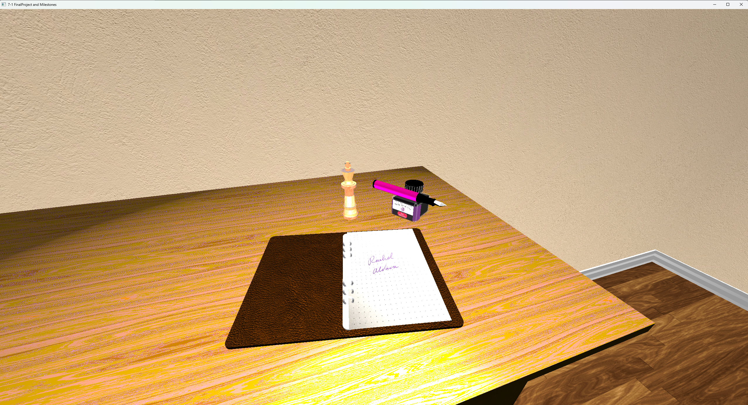

Consider the following images of objects on a wooden desk (a size a6 paper binder, a chess piece, an inkwell, and a fountain pen):

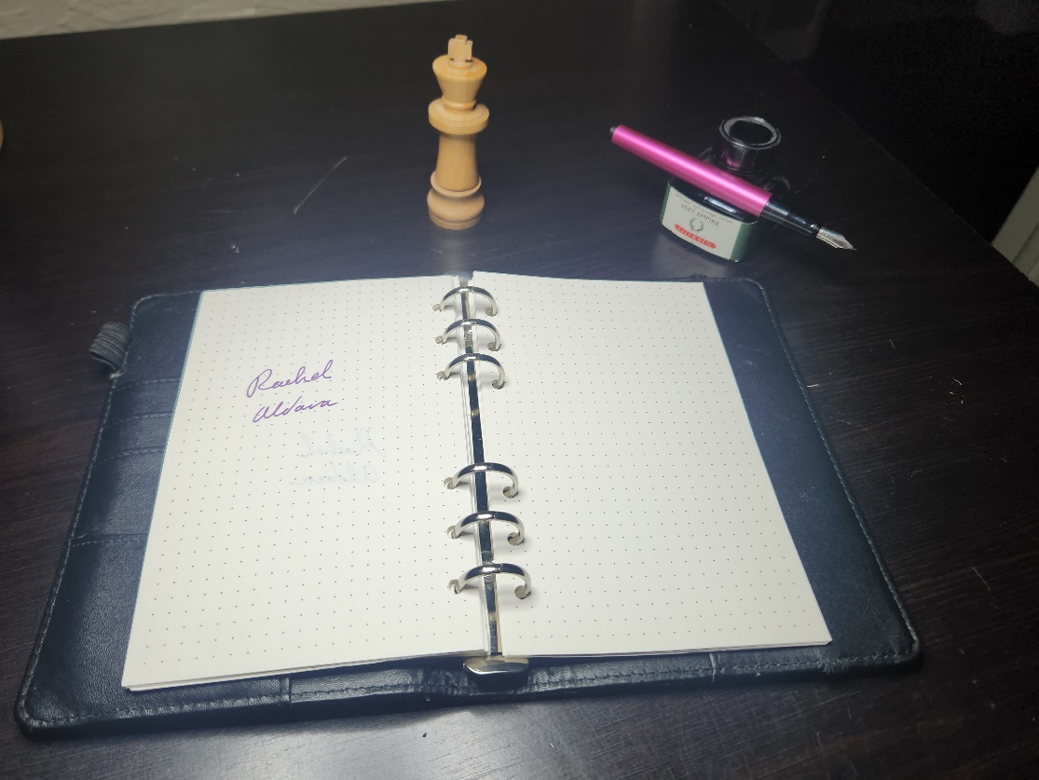

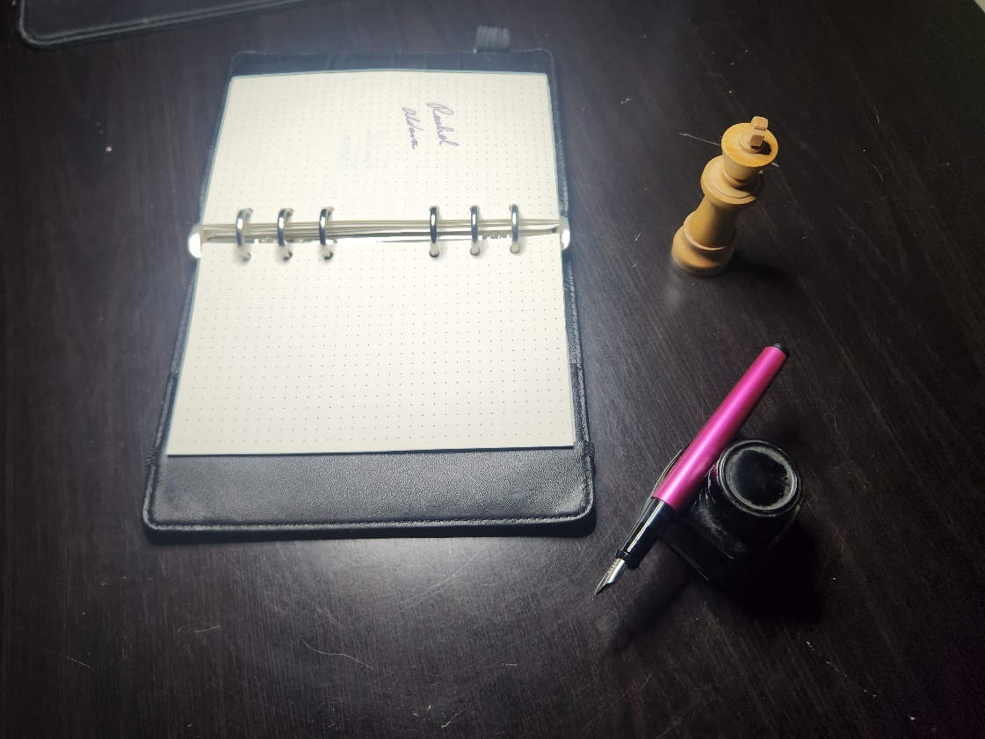

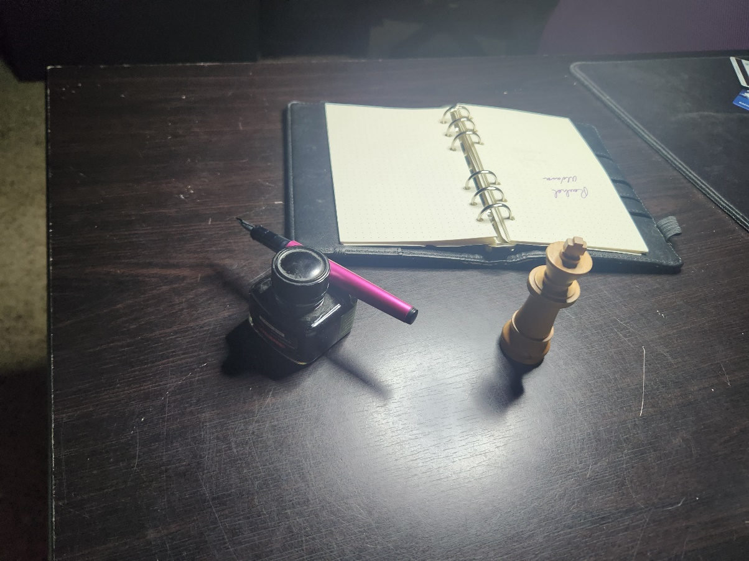

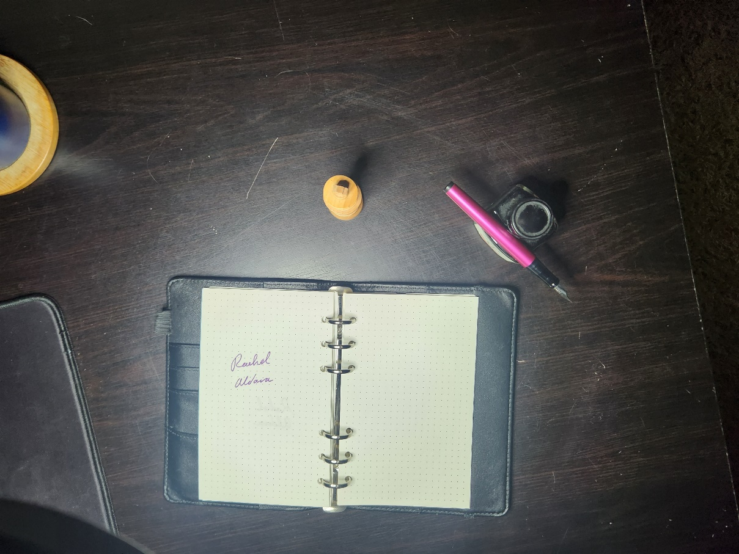

**Justify development choices for your 3D scene**

These items were selected initially because they were real objects which are regularly at my working environment. They each offer unique challenges which showcase different challenges.

The fact that I was able to pick up an item, inspect it, and take measurements, allowed me to quickly determine the size and proportions that I needed to input into the code.

**The binder:**

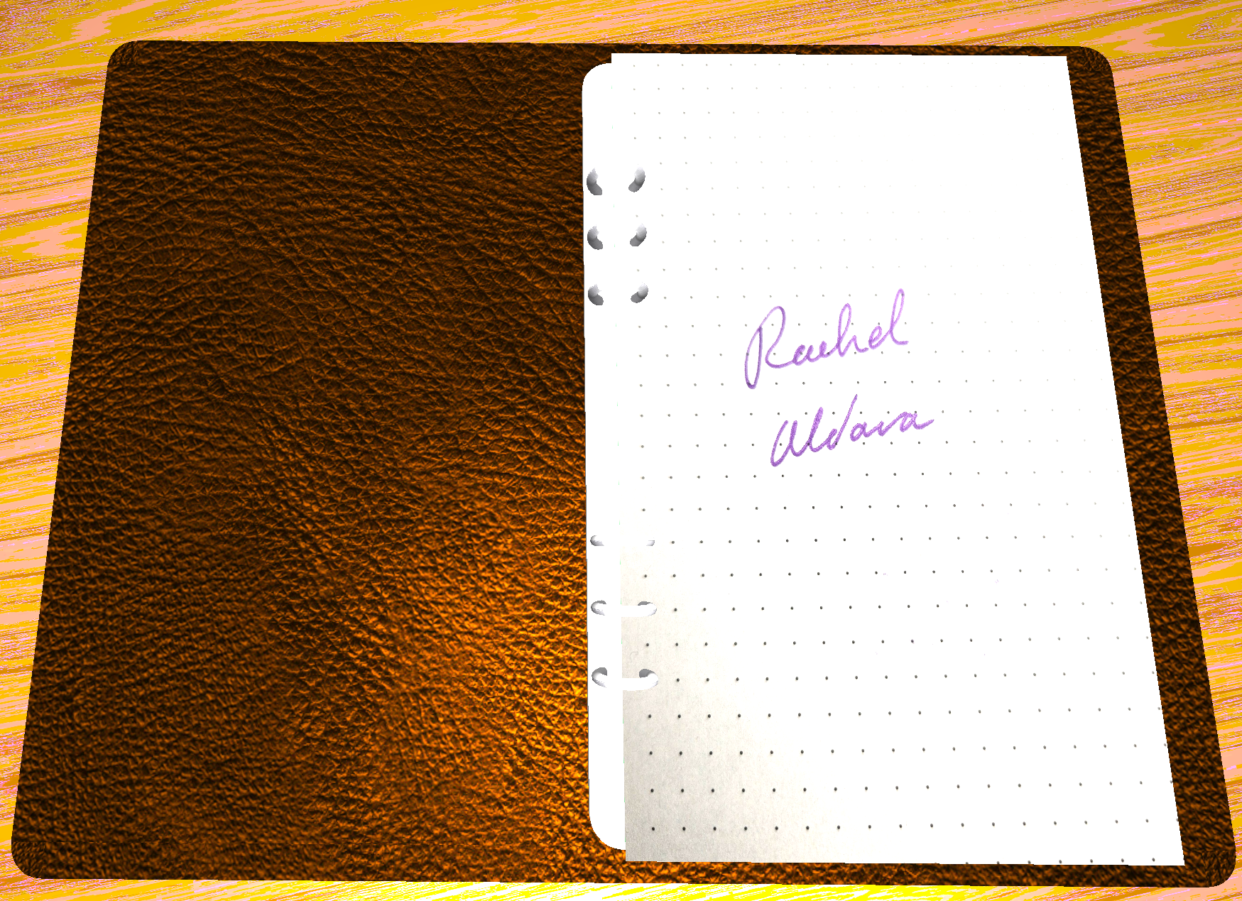

The binder was a challenge in applying my own texture from a self-sourced image into the scene. In this respect, my implementation of the binder was successful. It received the least amount of development time in part because the codebase handles lighting of curved objects differently than the lighting of a flat plane. The consequence of this is that I was unable to add rounded edges to the binder and to soften its appearance, because any rounded edges would receive radically different lighting.

**The Inkwell:**

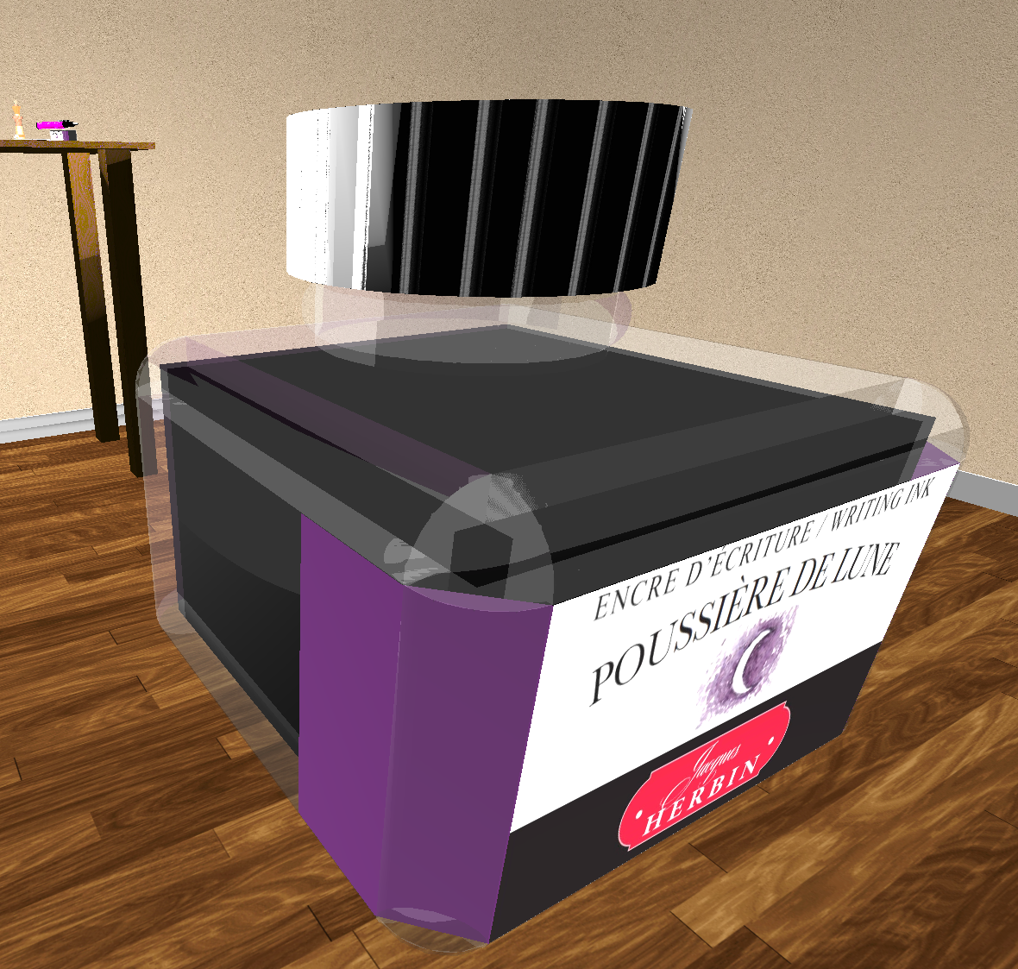

The inkwell was originally a challenge in applying a custom label texture. However, I decided to create it out of many more shapes than originally intended. I mentioned that the codebase applies light strangely to curved surfaces. I originally applied a purple color to the front cylinders, in order to make it appear as if the label wrapped around the object. Unfortunately, this caused the flat purple surface to have a different apparent color from the curved purple surface, thus ruining the effect. As a temporary measure, I reverted the cylinder back to the clear glass color and placed a purple plane inside the cylinder. This mimics the effect that I originally wanted. I suppose it works if you don’t look too closely. The glass has a material applied which subtly reflects purple light; I was hoping that it would give the effect that the ink inside was a highly concentrated purple.

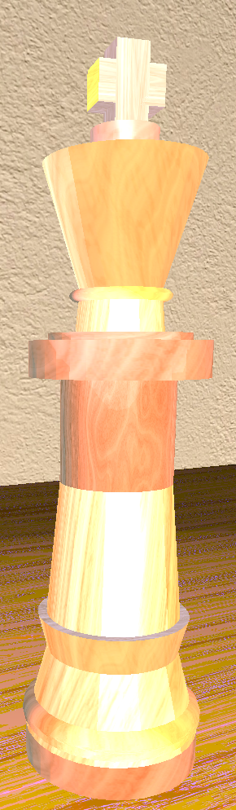

**The Chessman**

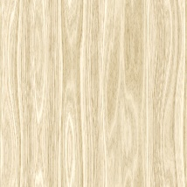 The chessman was intended to be the showcase of the complex object. It does satisfy the requirements, and I believe this object is the best looking out of the four, but the complexity of the inkwell exceeded this object. However, I am quite happy with my work involving lighting. The actual texture of the object is a light brown without much red. I was able to tune the ambient reflection colors to introduce red undertones into the object. In order to produce the white specular lighting, I had to consult the color wheel in order to find out which RGB values to adjust in order for a white glossy finish to result.

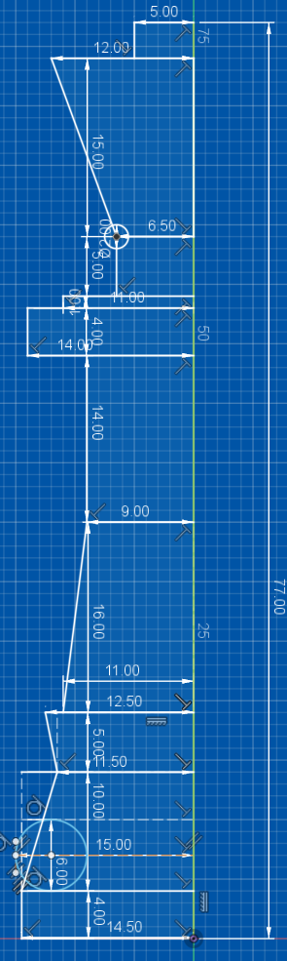

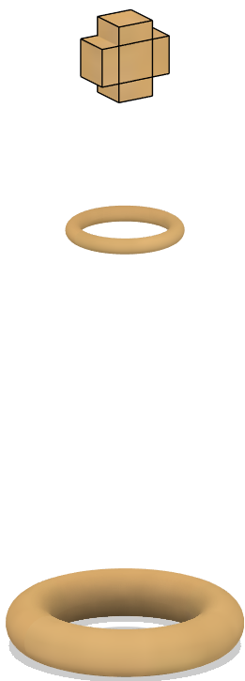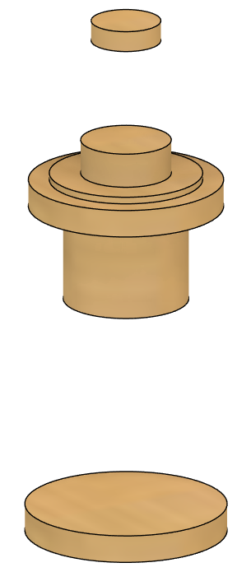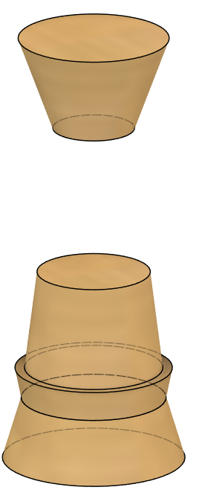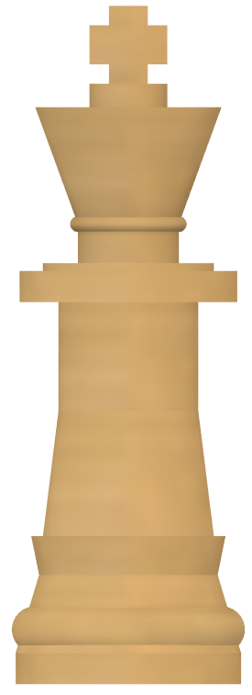

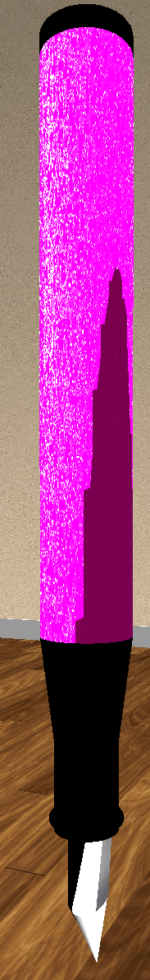**The Pen**

I wanted the pen to be an opportunity to allow me to create a custom mesh, if time allowed. I had thought that this would be a fun challenge, and it might indeed be a fun challenge, but I did not create a custom mesh. Instead, I focused on creating a versatile infrastructure which I will discuss in the next section. Using this infrastructure, I was able to create this object in about thirty minutes. The nib’s complicated and finely tuned transformations (from a cone and a tapered cylinder) would not have been feasible without this infrastructure.

Defining meshes in OpenGL is tedious. Modern CAD software can create more detailed meshes far more quickly. There are tools which can translate a CAD mesh into OpenGL, but they are beyond the scope of this project.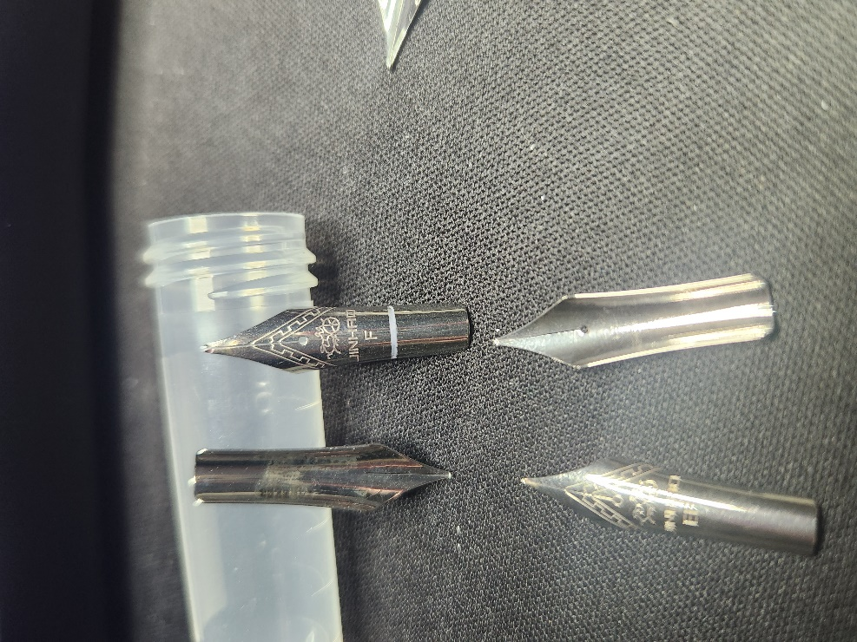

**Navigating the 3d scene**

The controls are not significantly different from those found in the starter code. The keymaps are defined in ViewManager.cpp. If one were to adapt this program for use with a controller or VR headset, one would need to add the keymappings to the relevant sections.

As it stands, a user can navigate via keyboard using WASD keys for basic camera positioning. The tilt and pan of the camera can be achieved by using a standard mouse. The camera can be moved vertically by using either the “q” or “e” keys. The speed of movement can be adjusted using the scroll wheel on the mouse.

Finally, users can use the “o” or “p” keys in order to hop to some pre-coded camera positions and projections. The “o” key will switch to a orthographic view whereas the “p” key will switch to a perspective view.

During testing, I implemented controls which could select, move, rotate, and resize objects, however this functionality exceeded the project specifications and the key bindings were removed.

**Custom functions and versatility**

I would say that I have the basic framework in place to create an environment for a simple 3d game. In a previous assignment I submitted code in which an object was traveling along a path while rotating. For this project I had intended on animating a chess board as if there was a game being played, but I needed to focus on other areas of the project. I hope to have implemented this animation by the time I upload it to github.

The reason my code supports animations is because I was able to abstract objects into what is essentially a glorified array of 4x4 vector matrices. Each object is a child of the Object class, each of which have different Shapes, but all share the same basic methods. These Objects have an associated 4x4 matrix which holds position, rotation, and size information. These Objects also have arrays containing multiple Shapes which each have 4x4 matrices. When an Object is moved, its matrix is updated to reflect the change in scale, rotation, or position. Each Shape that the Object contains receives an update to their matrix based off of the Object matrix. Each Shape contains at least one Surface. Each surface has either a color or a texture. It can also have a material, which informs how light affects it.

When the Render() method is called on an Object, each Shape receives a Render() command, which renders the Surfaces of the Shape.

Best of all, an Object can also have sub-Objects, which behave just as if they were Shapes. In this way, the entire scene has actually been defined as one object. If I were to edit this line of code:



And rotate the room 45 degrees in any direction, every single object within the room would be rotated and repositioned alongside it.

These methods should be adaptable to anything sufficiently similar to OpenGL, provided that objects are handled in a 4x4 matrix format.